Screen shot of arithmetic calculator

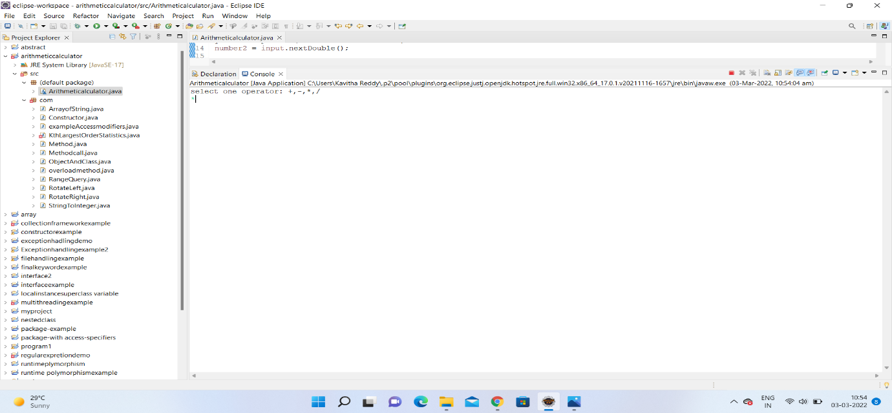

when we run our program we get this page we have to select one operator

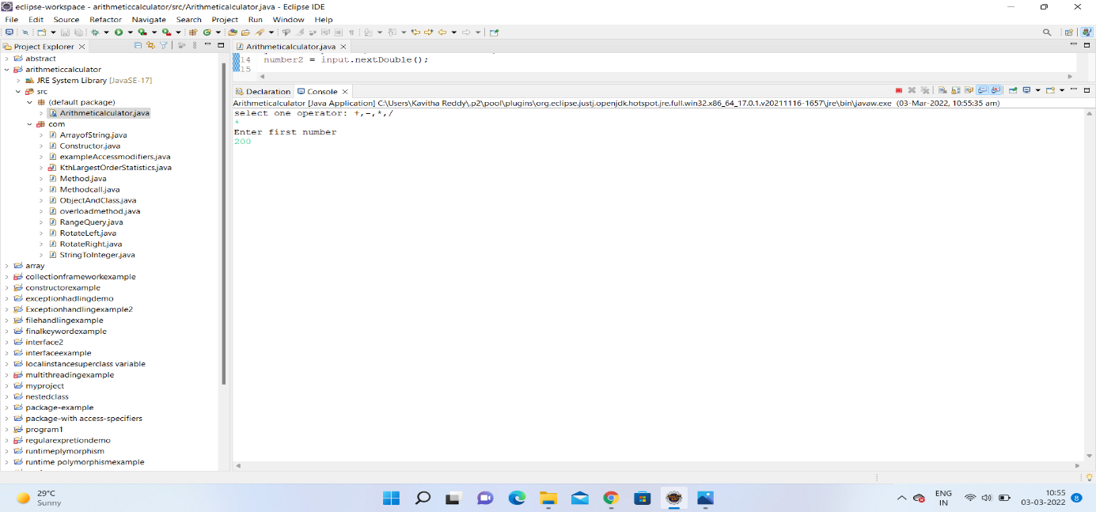

After Selecting We Have To Enter first number

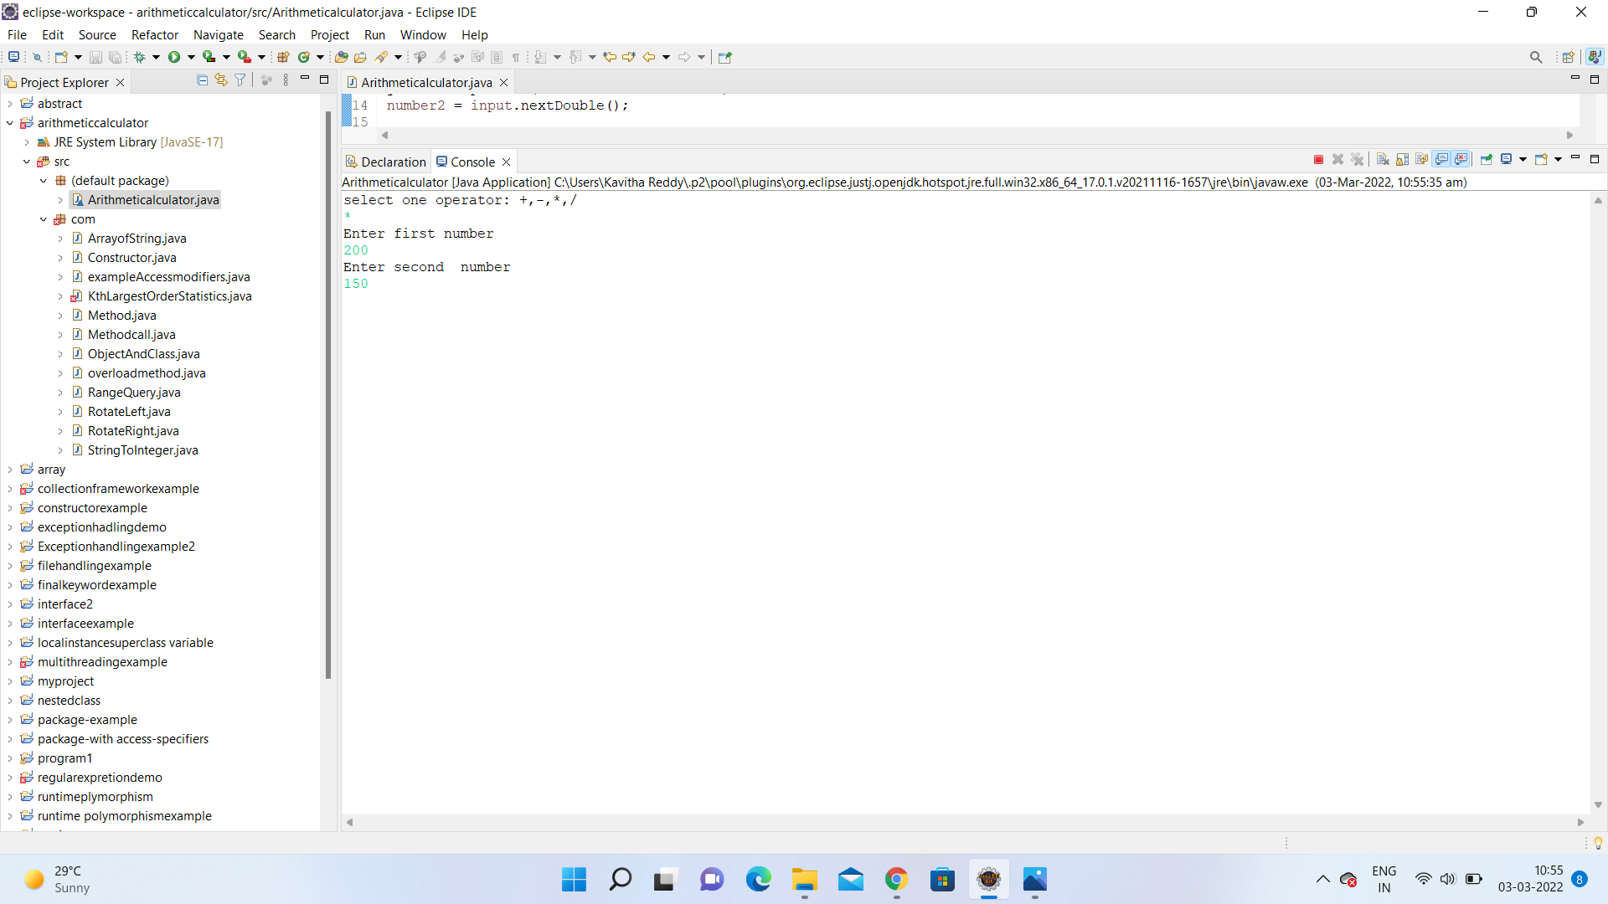

We have to enter second number

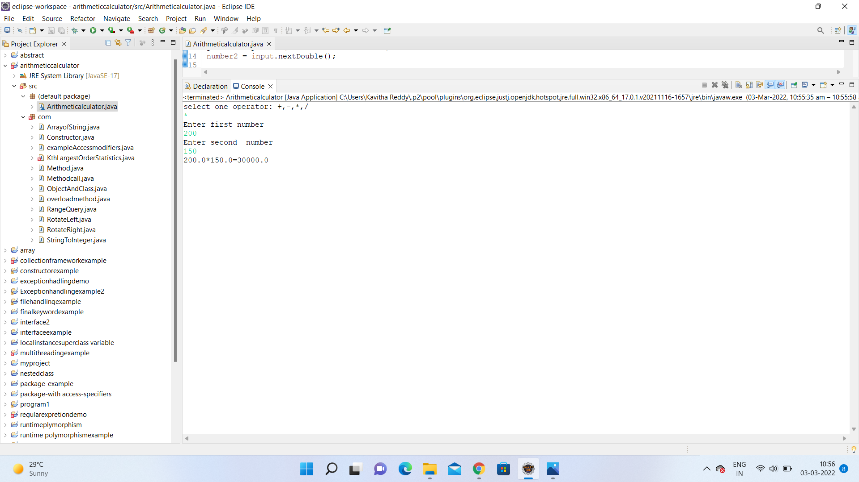

Finally we got output for multiplication